SIMATS ENGINEERING (SAVEETHA SCHOOL OF ENGINEERING)
Department of Computer Science and Engineering
CO1 ASSESSMENT TOOL 2 – Agile Sprint Planning & User Story Workshop

Course Code: | CSA10 / CSA1063 | Course Title: | Software Engineering
CO Assessed: | CO1 | Assessment: | Assessment Tool 2 – Agile Sprint Planning & User Story Workshop
Weightage: | 20% | Total Marks: | 25
CO1 Statement: | Apply advanced methodologies and agile project management techniques to manage software projects effectively
Student Name: | J. LOKESH | Reg. No.: | 192311216
Date: | 01/08/2026 | Duration: | 60 minutes

Code of Conduct
I am J. lokesh 192311216 (Name / Reg No) certify that this submission is my original work and that I have adhered to the guidelines specified for this assessment. I understand that any violation of academic integrity rules will result in disciplinary action.
Signature of the Student: J. LOKESH

Annexure A – Agile Sprint Planning & User Story Workshop
Smart Tax Calculation and Financial Planning Management System
- Identify the Project Vision and Stakeholders
  - Define the project's vision, objectives, and identify all key stakeholders involved.
Project Vision:
The Smart Tax Calculation and Financial Planning Management System is designed to provide an intelligent, secure, and user-friendly platform that simplifies tax calculation and financial planning for individuals and businesses. The system automates the process of calculating taxes based on the user's income, deductions, exemptions, and applicable tax regulations, reducing manual effort and minimizing errors.
Project Objectives
The main objectives of the Smart Tax Calculation and Financial Planning Management System are:
1. Automate Tax Calculation
Develop a system that accurately calculates taxes based on user income, deductions, exemptions, and current tax regulations, reducing manual calculations and human errors.
2. Simplify Financial Planning
Provide users with tools to manage income, expenses, savings, and investments to support effective financial planning and budgeting.
3. Maintain Secure Financial Records
Store users' financial information securely using authentication, authorization, and data encryption to ensure confidentiality and data protection.
4. Generate Comprehensive Reports
Enable users to generate detailed tax reports, financial summaries, expense reports, and downloadable documents for personal records or official purposes.
5. Provide Tax-Saving Recommendations
Suggest eligible tax-saving investments and deductions based on the user's financial profile to help legally reduce tax liability.
6. Improve Financial Decision-Making
Offer dashboards, graphical analysis, and financial insights that help users monitor spending patterns, savings, and investment performance.
7. Ensure Compliance with Tax Regulations
Keep the system updated with the latest tax rules and government regulations to ensure accurate calculations and compliance.
8. Deliver a User-Friendly Experience
Develop an intuitive, responsive, and easy-to-use interface that allows users to access the application from various devices with minimal technical knowledge.
Key Stakeholders
1. End Users (Taxpayers)
End users are the primary users of the system. They use the application to enter their income, deductions, and investment details, calculate taxes automatically, manage expenses, and generate tax and financial reports.
2. Financial Advisors
Financial advisors help users with tax planning and financial management. They analyze financial data, recommend tax-saving investments, and provide guidance to improve users' financial planning.
3. System Administrator
The system administrator manages the overall application. They are responsible for creating and managing user accounts, maintaining system security, updating tax rules, and ensuring the system runs smoothly.
4. Tax Authorities
Tax authorities are government agencies that define tax laws and regulations. They ensure that the system follows the latest tax rules and that generated tax reports comply with legal requirements.
5. Project Manager
The project manager plans, coordinates, and monitors the software development process. They manage project schedules, allocate tasks to the development team, and ensure that the project is completed on time.
6. Software Development Team
The development team designs, develops, and maintains the application. They implement system features, integrate the database, fix software bugs, and improve the overall performance of the system.
7. Quality Assurance (QA) Team
The QA team tests the application to ensure it functions correctly. They identify software defects, verify tax calculations, and ensure that the system meets quality and performance standards.
8. Database Administrator (DBA)
The Database Administrator manages the application's database. They ensure secure storage of financial data, perform backups, maintain database performance, and protect data from unauthorized access.
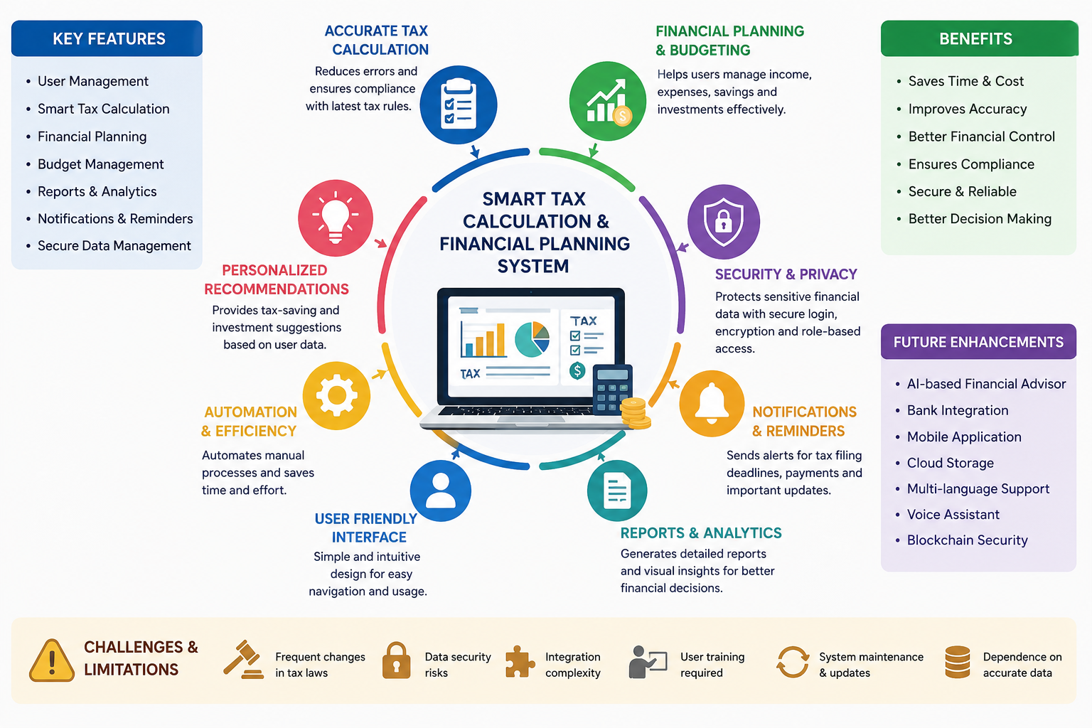
- Create Epics and User Stories
  - Break down the requirements into Epics and formulate well-structured User Stories using the format:
As a <user>, I want <feature>, so that <benefit>.
Epic 1: User Management
Description: This epic focuses on managing user accounts, including registration, login, profile management, and secure authentication.
User Stories
- US1: As a new user, I want to register an account, so that I can access the system securely.
- US2: As a registered user, I want to log in using my credentials, so that I can securely access my financial information.
- US3: As a user, I want to update my profile information, so that my personal details remain accurate.

Epic 2: Tax Calculation
Description: This epic enables users to calculate their taxes automatically based on income, deductions, and applicable tax rules.
User Stories
- US4: As a taxpayer, I want to enter my income details, so that the system can calculate my tax automatically.
- US5: As a taxpayer, I want to enter deductions and exemptions, so that my tax liability is calculated accurately.
- US6: As a taxpayer, I want to view my tax calculation summary, so that I know the amount of tax I need to pay.

Epic 3: Financial Planning
Description: This epic helps users manage their finances through expense tracking, budgeting, and investment recommendations.
User Stories
- US7: As a user, I want to track my income and expenses, so that I can manage my budget effectively.
- US8: As a user, I want to receive tax-saving investment suggestions, so that I can reduce my tax liability and increase savings.
- US9: As a user, I want to view my financial dashboard, so that I can monitor my financial status easily.

Epic 4: Reports and Analytics
Description: This epic provides detailed tax reports and financial summaries for users.
User Stories
- US10: As a user, I want to generate tax reports, so that I can use them for tax filing and record keeping.
- US11: As a user, I want to download financial reports in PDF format, so that I can save or share them whenever needed.
- US12: As a user, I want to view graphical financial reports, so that I can better understand my income, expenses, and savings.

- Define Acceptance Criteria
  - Write clear and measurable acceptance criteria for each selected user story using the Given–When–Then format or equivalent.
User Story 1: User Registration
User Story:
As a new user, I want to register an account, so that I can access the system securely.
Acceptance Criteria:
- Given the user enters valid registration details,
- When the user clicks the Register button,
- Then the account should be created successfully and a confirmation message should be displayed.

User Story 2: User Login
User Story:
As a registered user, I want to log in using my credentials, so that I can securely access my financial information.
Acceptance Criteria:
- Given the user has a registered account,
- When the user enters the correct username and password,
- Then the system should log the user in and display the dashboard.

User Story 3: Income Entry
User Story:
As a taxpayer, I want to enter my income details, so that the system can calculate my tax automatically.
Acceptance Criteria:
- Given the user is logged in,
- When the user enters valid income details and clicks Save,
- Then the income information should be stored successfully.

User Story 4: Tax Calculation
User Story:
As a taxpayer, I want to view my tax calculation summary, so that I know the amount of tax I need to pay.
Acceptance Criteria:
- Given the user has entered income and deduction details,
- When the user clicks Calculate Tax,
- Then the system should display the correct tax amount along with a tax summary.

User Story 5: Expense Tracking
User Story:
As a user, I want to track my income and expenses, so that I can manage my budget effectively.
Acceptance Criteria:
- Given the user enters expense details,
- When the user clicks Save,
- Then the expense should be recorded and displayed in the expense list.

User Story 6: Tax Report Generation
User Story:
As a user, I want to generate tax reports, so that I can use them for tax filing and record keeping.
Acceptance Criteria:
- Given the tax calculation is completed,
- When the user clicks Generate Report,
- Then the system should generate and display the tax report with accurate details.

- Prioritize the Product Backlog
  - Organize and prioritize the product backlog based on business value, customer needs, and project dependencies.
The product backlog is prioritized based on business value, customer needs, and project dependencies. Features that are essential for the basic functioning of the system are given the highest priority, while additional and enhancement features are scheduled for later development.
High Priority
1. User Registration
Business Value: High
Reason: User registration is the first step in using the application. It allows new users to create an account and securely access the system.
2. User Login
Business Value: High
Reason: Login functionality is necessary to authenticate users and protect their financial information from unauthorized access.
3. Income Entry
Business Value: High
Reason: Users must enter their income details before the system can calculate taxes. This feature is a dependency for tax calculation.
4. Tax Calculation
Business Value: High
Reason: Tax calculation is the core feature of the application. It provides users with accurate tax amounts based on their financial information.

Medium Priority
5. Expense Tracking
Business Value: Medium
Reason: This feature helps users record and monitor their expenses, making financial planning more effective.
6. Tax-Saving Recommendations
Business Value: Medium
Reason: The system suggests eligible tax-saving investments and deductions, helping users reduce their tax liability.
7. Financial Dashboard
Business Value: Medium
Reason: The dashboard provides a summary of income, expenses, savings, and tax details, allowing users to monitor their financial status easily.

Low Priority
8. Tax Report Generation
Business Value: Low
Reason: This feature generates detailed tax reports after tax calculation is completed. It is useful but depends on the core tax calculation functionality.
9. Download Reports
Business Value: Low
Reason: Users can download tax and financial reports in PDF format for future reference or official purposes. This is an additional convenience feature.
10. Profile Management
Business Value: Low
Reason: Users can update their personal information and account settings. While important, it is not essential for the initial version of the system.

- Plan the Sprint Backlog
  - Select high-priority user stories for the first sprint and divide them into actionable development tasks.
Sprint 1 Overview
The first sprint focuses on implementing the core functionalities of the Smart Tax Calculation and Financial Planning Management System. High-priority user stories are selected to ensure users can register, log in, enter income details, and calculate taxes successfully.

Selected High-Priority User Stories
User Story 1: User Registration
As a new user, I want to register an account, so that I can access the system securely.
Development Tasks:
- Design the registration page.
- Create the user registration form.
- Validate user input.
- Store user details in the database.
- Test the registration functionality.

User Story 2: User Login
As a registered user, I want to log in using my credentials, so that I can securely access my financial information.

Development Tasks:
- Design the login page.
- Implement user authentication.
- Validate login credentials.
- Redirect users to the dashboard after successful login.
- Test the login functionality.

User Story 3: Income Entry
As a taxpayer, I want to enter my income details, so that the system can calculate my tax automatically.
Development Tasks:
- Design the income entry form.
- Add input validation for income details.
- Store income data in the database.
- Retrieve saved income information.
- Test the income entry module.

User Story 4: Tax Calculation
As a taxpayer, I want to view my tax calculation summary, so that I know the amount of tax I need to pay.
Development Tasks:
- Develop the tax calculation algorithm.
- Apply current tax rules and tax slabs.
- Calculate the total tax amount.
- Display the tax summary on the dashboard.
- Test tax calculation accuracy.

Sprint Goal
To develop the core features of the system by enabling secure user authentication and accurate tax calculation based on user income.

- Estimate Effort Using Story Points
  - Assign story points to each selected user story using an appropriate estimation technique (e.g., Fibonacci sequence or Planning Poker) and justify your estimates.
The effort for each user story is estimated using the Fibonacci Sequence (1, 2, 3, 5, 8, 13). This technique is commonly used in Agile because it helps estimate the relative complexity, effort, and uncertainty involved in completing each user story.

User Story 1: User Registration
Story Points: 3
Justification:
The registration feature involves creating a user interface, validating user input, and storing user details in the database. It is a basic functionality with relatively low complexity.

User Story 2: User Login
Story Points: 5
Justification:
The login feature requires user authentication, password verification, session management, and security measures, making it moderately complex.

User Story 3: Income Entry
Story Points: 5
Justification:
This feature includes designing an income entry form, validating financial data, storing records in the database, and ensuring data accuracy. It requires moderate development effort.

User Story 4: Tax Calculation
Story Points: 8
Justification:
Tax calculation is the core functionality of the system. It involves implementing tax rules, deductions, exemptions, and calculation logic, making it the most complex feature in the first sprint.

Total Story Points
The total effort for Sprint 1 is 21 Story Points.

Estimation Summary
- User Registration – 3 Story Points
- User Login – 5 Story Points
- Income Entry – 5 Story Points
- Tax Calculation – 8 Story Points
The total of 21 Story Points represents a manageable workload for the first sprint and covers the essential functionalities required to build a working prototype of the Smart Tax Calculation and Financial Planning Management System.

- Present the Sprint Goal and Expected Deliverables
  - Define a clear sprint goal and describe the expected sprint deliverables, including the features to be completed at the end of the sprint.
Sprint Goal
The goal of Sprint 1 is to develop the core functionalities of the Smart Tax Calculation and Financial Planning Management System. By the end of the sprint, users should be able to register an account, log in securely, enter their income details, and calculate their tax accurately. This sprint establishes the foundation for future features such as financial planning, expense tracking, and report generation.

Expected Sprint Deliverables
1. User Registration Module
A fully functional registration feature that allows new users to create an account securely.
2. User Login Module
A secure login system that authenticates users and provides access to their personal dashboard.
3. Income Entry Module
A form that enables users to enter and save their income details for tax calculation.
4. Tax Calculation Module
A feature that automatically calculates the user's tax based on the entered income and displays the tax summary.
5. Database Integration
A connected database to securely store user accounts and financial information.
6. Basic User Dashboard
A dashboard where users can access their profile, income details, and calculated tax information.
7. Tested Core Features
All implemented modules are tested to ensure they work correctly and meet the defined acceptance criteria.

Features Completed at the End of Sprint
- User Registration
- User Login
- Income Entry
- Automatic Tax Calculation
- Database Integration
- Basic User Dashboard
- Testing of Implemented Features

Sprint Outcome
At the end of Sprint 1, the system will provide a working prototype that allows users to securely access the application, enter their income details, and calculate their taxes accurately. This completed functionality forms the foundation for implementing advanced features such as expense tracking, financial planning, tax-saving recommendations, and report generation in future sprints.

Rubrics for Calculation
Criteria | Excellent (5 Marks) | Good (3 Marks) | Satisfactory (2 Marks) | Needs Improvement (1 Mark)
Project Vision & Stakeholder Identification | Project vision is clear, comprehensive, and aligned with the problem statement. All relevant stakeholders and their roles are correctly identified. | Vision is clear with minor omissions. Most stakeholders are correctly identified. | Vision is partially defined. Some stakeholders are missing or incorrectly identified. | Vision is unclear or incomplete. Stakeholders are poorly identified or missing.
Epics & User Stories | Epics are well-defined and user stories are complete, follow Agile format, and fully capture functional requirements. | Epics and user stories are mostly complete with minor formatting or requirement issues. | User stories are partially complete with limited Agile structure. | User stories are incomplete, unclear, or do not follow Agile practices.
Acceptance Criteria | Acceptance criteria are specific, measurable, testable, and aligned with all user stories. | Acceptance criteria are mostly clear and testable with minor gaps. | Acceptance criteria are partially defined and lack clarity or completeness. | Acceptance criteria are missing or not aligned with user stories.
Product Backlog Prioritization & Sprint Planning | Product backlog is logically prioritized, sprint backlog is realistic, and task breakdown is complete. | Backlog prioritization and sprint planning are mostly appropriate with minor issues. | Prioritization or sprint planning is partially complete with limited justification. | Backlog prioritization and sprint planning are poorly organized or incomplete.
Story Point Estimation, Sprint Goal & Presentation | Story point estimation is well justified, sprint goal is clear, deliverables are realistic, and presentation is professional and well organized. | Estimation and sprint goal are mostly appropriate with minor inconsistencies. Presentation is clear. | Estimation or sprint goal lacks justification. Presentation is adequate but incomplete. | Estimation is unrealistic or missing. Sprint goal, deliverables, and presentation are unclear or incomplete.

